Shows the program handling invalid input, then the edge case of 1 number.  
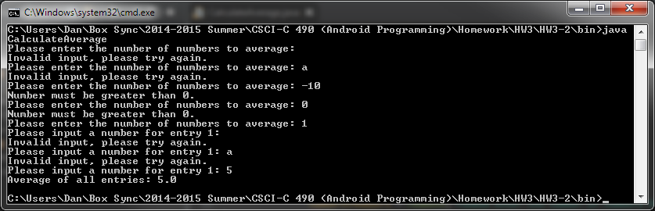

Shows handling 3 numbers.  
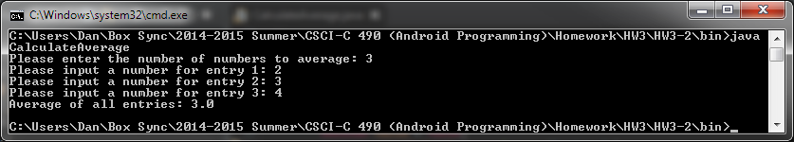

Shows handling 10 numbers.  
